**Evidence for Project Unit**

Dan Kelsey

Cohort e15

01/09/17

**P5 – User Sitemap**

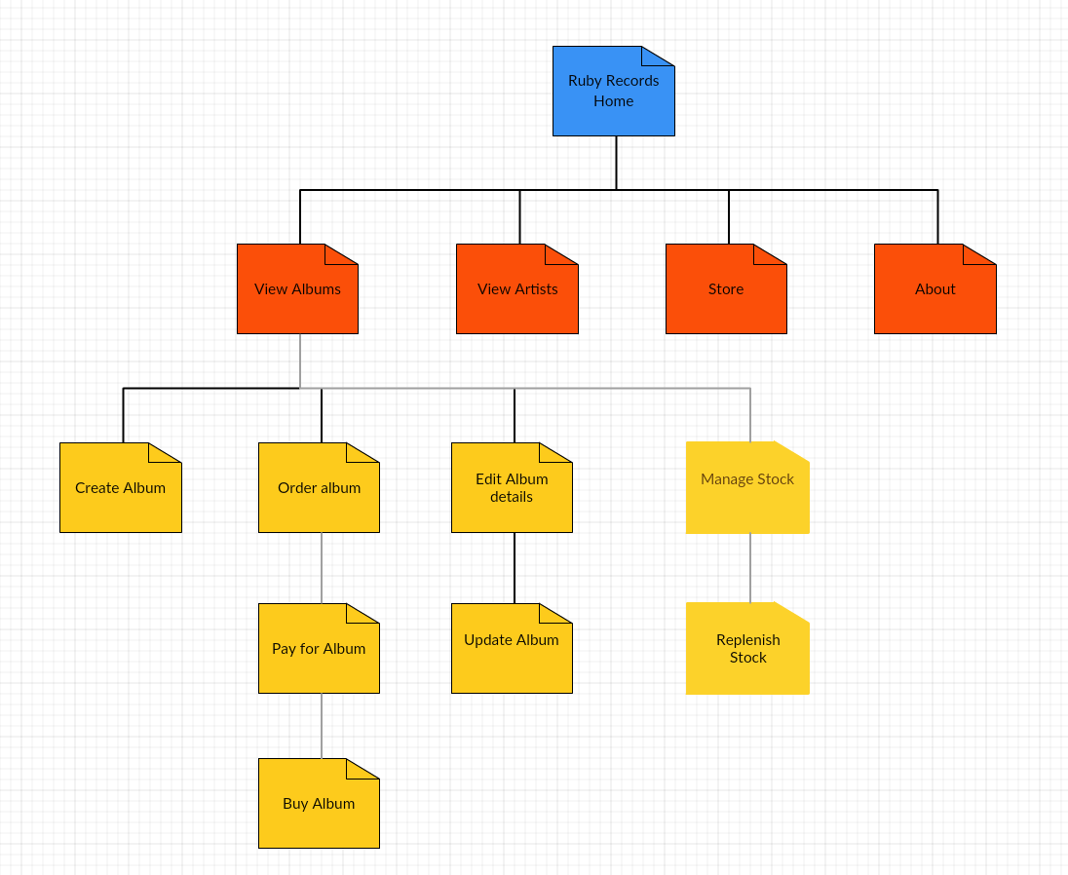

**P6 – Two wireframes**

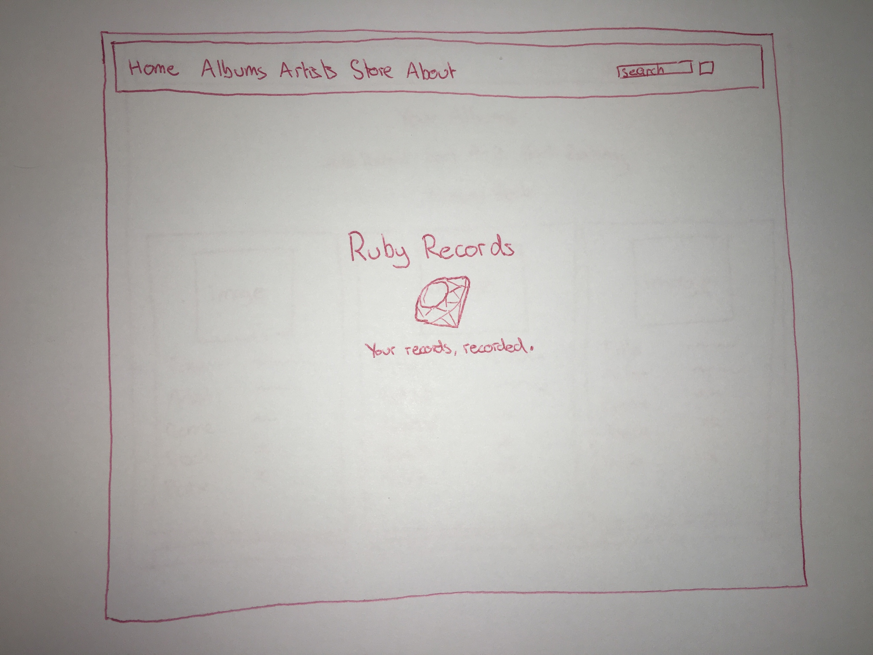

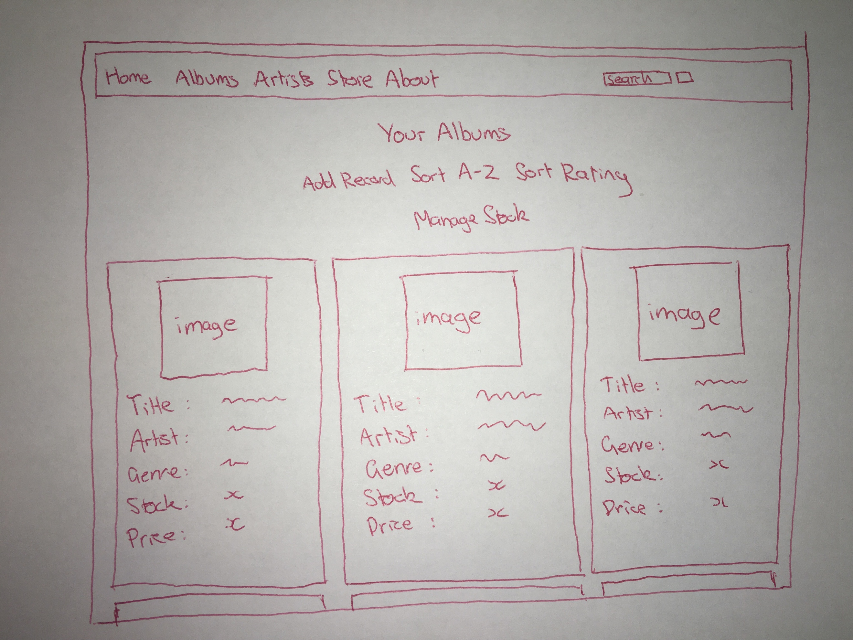

**P10 - Pseudocode**

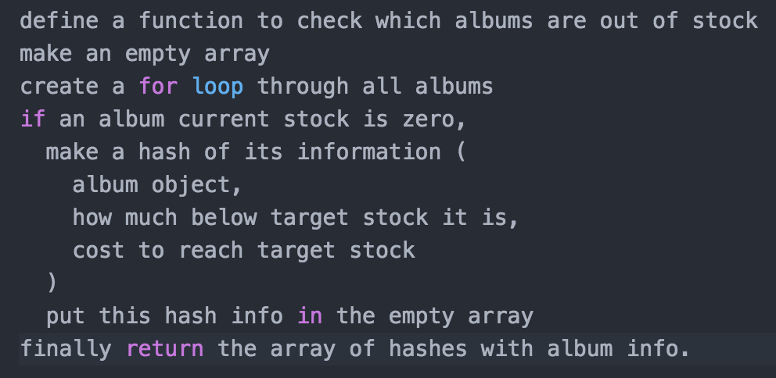

**P13 – Show user input being processed according to design requirements**



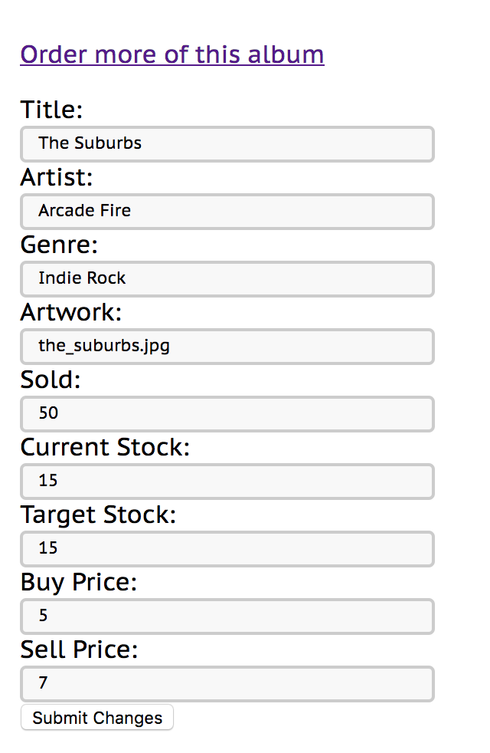

**P14 – Show an interaction with data persistence**

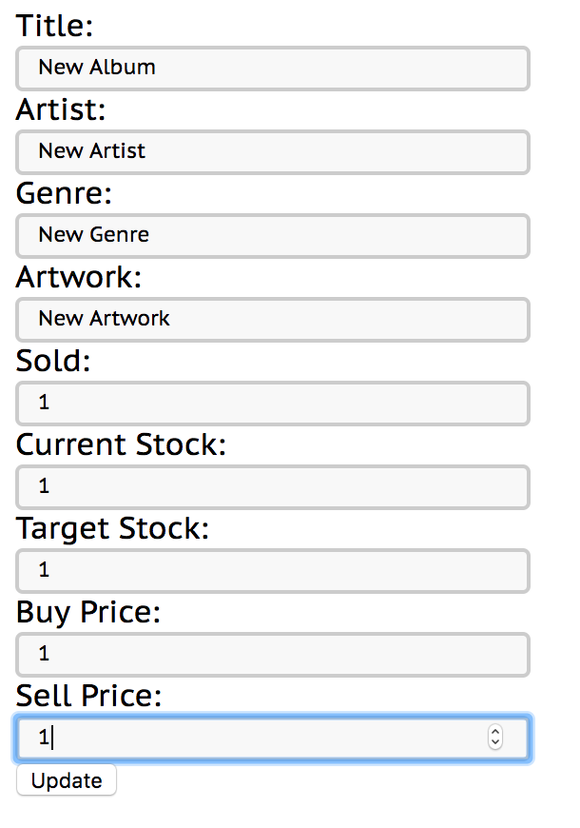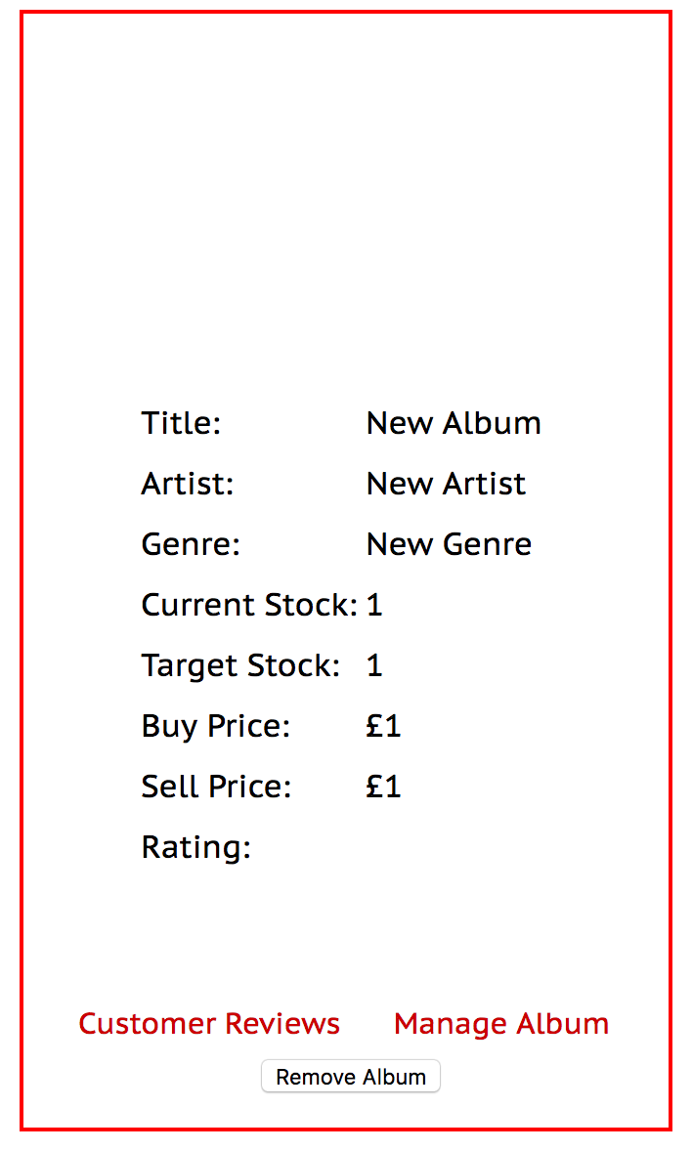

**P15 – Show the correct output of results and feedback to the user.**

